Federalism
What is federalism?

Why is it necessary?

How is power shared in the American government?

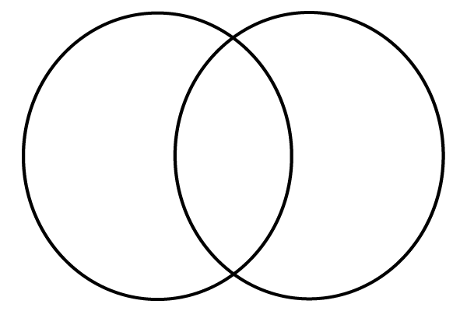
Shared
State
National

